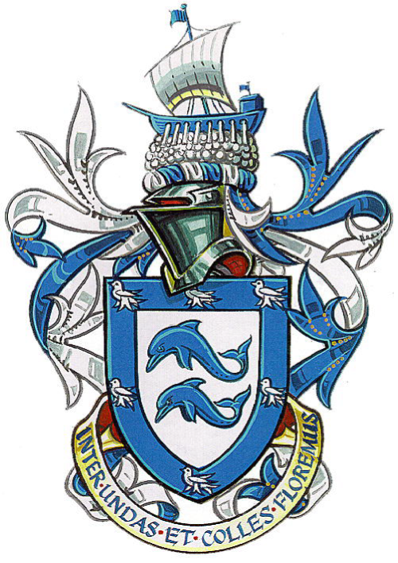

The Mayor and Mayoress of Brighton & Hove, Cllr Brian Fitch & Mrs Norah Fitch
invite you to book for a

Reception to celebrate the life of Martha Gunn
to be held at the Mayors Parlour, Brighton Town Hall

on Friday 1st May 2015
6.00pm - 7.30pm

Tickets £15

Dress code: Smart Casual or Period dress

Martha Gunn, née Killick, the famous Brighton ‘Dipper’ died 200 years ago this coming 2nd May 2015.
Local ‘experts’ on Martha and her involvement with the Price of Wales, later George 1V will be present. It is hoped that descendants from the Gunn and Killick families will be able to attend and make contact.
Family Name Badges, where appropriate, will be issued on arrival.
For further details or queries please contact Martyn Bell (Collings-Killick family) at marthagunn200@hotmail.co.uk or telephone 07505 215347

Tickets can be purchased by cheque payable to ‘The Mayor’s Charities’ and sent to:
The Mayors Parlour, Brighton Town Hall, Bartholomew Square, Brighton BN1 1JA.
Please note numbers are strictly limited and no reservation will be confirmed without payment.

Please enclose your home address and email for confirmation purposes and if you wish, brief details of your ancestral link to Martha Gunn née Killick.

Please call 01273 291225 or email Mayorsoffice@brighton-hove.gov.uk



